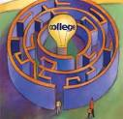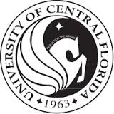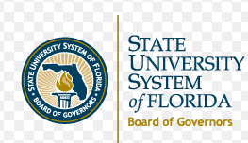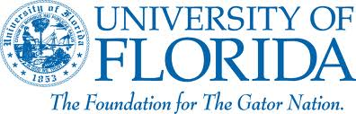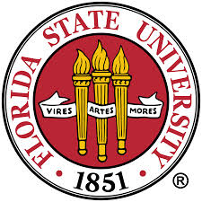 [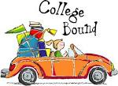](http://www.google.com/imgres?imgurl=http://www.stmarkscarmel.org/clientimages/29184/images/youth/college_130c.jpg&imgrefurl=http://www.stmarkscarmel.org/college&usg=__e1a5pjJK4XSjZolphdTsRlKHz5s=&h=983&w=1350&sz=466&hl=en&start=8&zoom=1&tbnid=Ud5zKTwV5F77vM:&tbnh=109&tbnw=150&ei=8RYxUpTZC4SA8gTX4oH4Bw&prev=/search?q=college&um=1&client=firefox-a&rls=org.mozilla:en-US:official&hl=en&tbm=isch&um=1&itbs=1&sa=X&ved=0CDoQrQMwBw)

**TOTAL COST: $460.00**

PRINT ONLINE RECEIPTS AND TURN INTO MS. ANCONA (GIRLS PE TEACHER)

crystallake.browardschools.com

## **Payment Dates**

## **and Amounts**

|  |  |  |
| --- | --- | --- |
| **NON-REFUNDABLE****1ST. PAYMENT****ONLINE ONLY** | **$150.00** | **BY TUESDAY****NOVEMBER****19TH** |
| **NON-REFUNDABLE****2nd PAYMENT****ONLINE ONLY** | **$152.00** | **BY** **TUESDAY****DECEMBER****17TH** |
| **NON-REFUNDABLE****3rd PAYMENT****ONLINE ONLY** | **$158.00** | **BY** **TUESDAY****JANUARY****14TH** |

3551 NE 3rd Avenue  
Pompano Beach, FL 33064

Principal: Earnest Toliver

crystallake.browardschools.com

Trip Coordinator Cindi Ancona

Cindi.ancona@browardschools.com

Crystal Lake Middle School

Crystal Lake Middle School

**8th Grade College Tour**

**2020**

### ***Projected Itinerary***

***Wednesday - March 11, 2020***

5:00AM - passenger motor coach arrives at Crystal Lake Middle School – 3551 NE 3rd Avenue, Pompano Beach, FL 33064 – School number: 754-322-3100

5:30AM - Depart from the school for Daytona

7:00AM – Brief stop at St. Lucie county rest area for restroom break

10:00AM - Self-Guided Tourof **Bethune-Cookman University** – 640 Dr. Mary McLeod Bethune Blvd. Daytona, Beach FL 32114 school is on SPRING BREAK

11:15AM – Depart Bethune Cookman college for lunch at Volusia Mall Food Court1700 W International speedway Daytona Beach **(At Students’ expense)**

**12:30 PM Depart for Gainesville**

3:00PM - Self-guided tourof **University of Florida –** 303 W. University Avenue – Gainesville, FL 32601

4:30PM - Depart for Tallahassee

7:00PM - Dinner at **Chik-Fil-A** 2308 Apalachee Pkwy Tallahassee **PRE-ORDERS NO COST TO STUDENT**

9:00PM - Check into Hotel: **FOUR POINTS BY SHERATON** 11233 Sterling Rd Inverness Fl 34450

***Thursday – March 12, 2020***

7:00AM - Buffet breakfast at the hotel **(Included)**

8:00 AM - Depart from hotel

8:30 AM (Self- guided)tour of **Florida State University –** 644 W. Call Street Tallahassee, FL 32304

10:30AM (Self- Guided Tour)of **Florida A & M University –** 1601 S. Martin Luther King Jr. Blvd. Tallahassee, FL 32307

11:45 AM **Lunch at the FAMU Café (Included)**

1:15PM **Florida Historic Capital Museum** (confirmed) 400 S Monroe St. Tallahassee Fl 32399 45 minute Scavenger Hunt

2:30PM Depart for Orlando bathroom break en route

7:00 PM Arrive for dinner Disney Springs 1486 Buena Vista dr. Orlando (**Students will receive $20.00)**

10:00PM Check into hotel – **Holiday Inn Express & Suites Orlando-5605 Major Blvd. Orlando**

***Friday – March 13, 2020***

7:00AM - Full buffet breakfast at hotel **(Included)**

8:00AM - Depart hotel for the day

9:00AM Self -Guided tour of **University of Central Florida –** University of Central Florida, Orlando FL

10:30AM - Depart for Universal Studios – 6000 Universal Blvd. Orlando, FL 32819

**Lunch/Dinner Card** - Each participant will receive $ 25.00 that can be used for lunch and dinner at the park

6:00PM - Load buses

8:00 PM Brief stop at Fort Drum Service Plaza for bathroom and SNACK break (students expense)

10:30PM - Approximate arrival time to Crystal Lake Middle School.